ASSIGNMENT - 03

PYTHON FOR DATA SCIENCE

VISHWAS KISANIYA

22106027

CSE(DS)

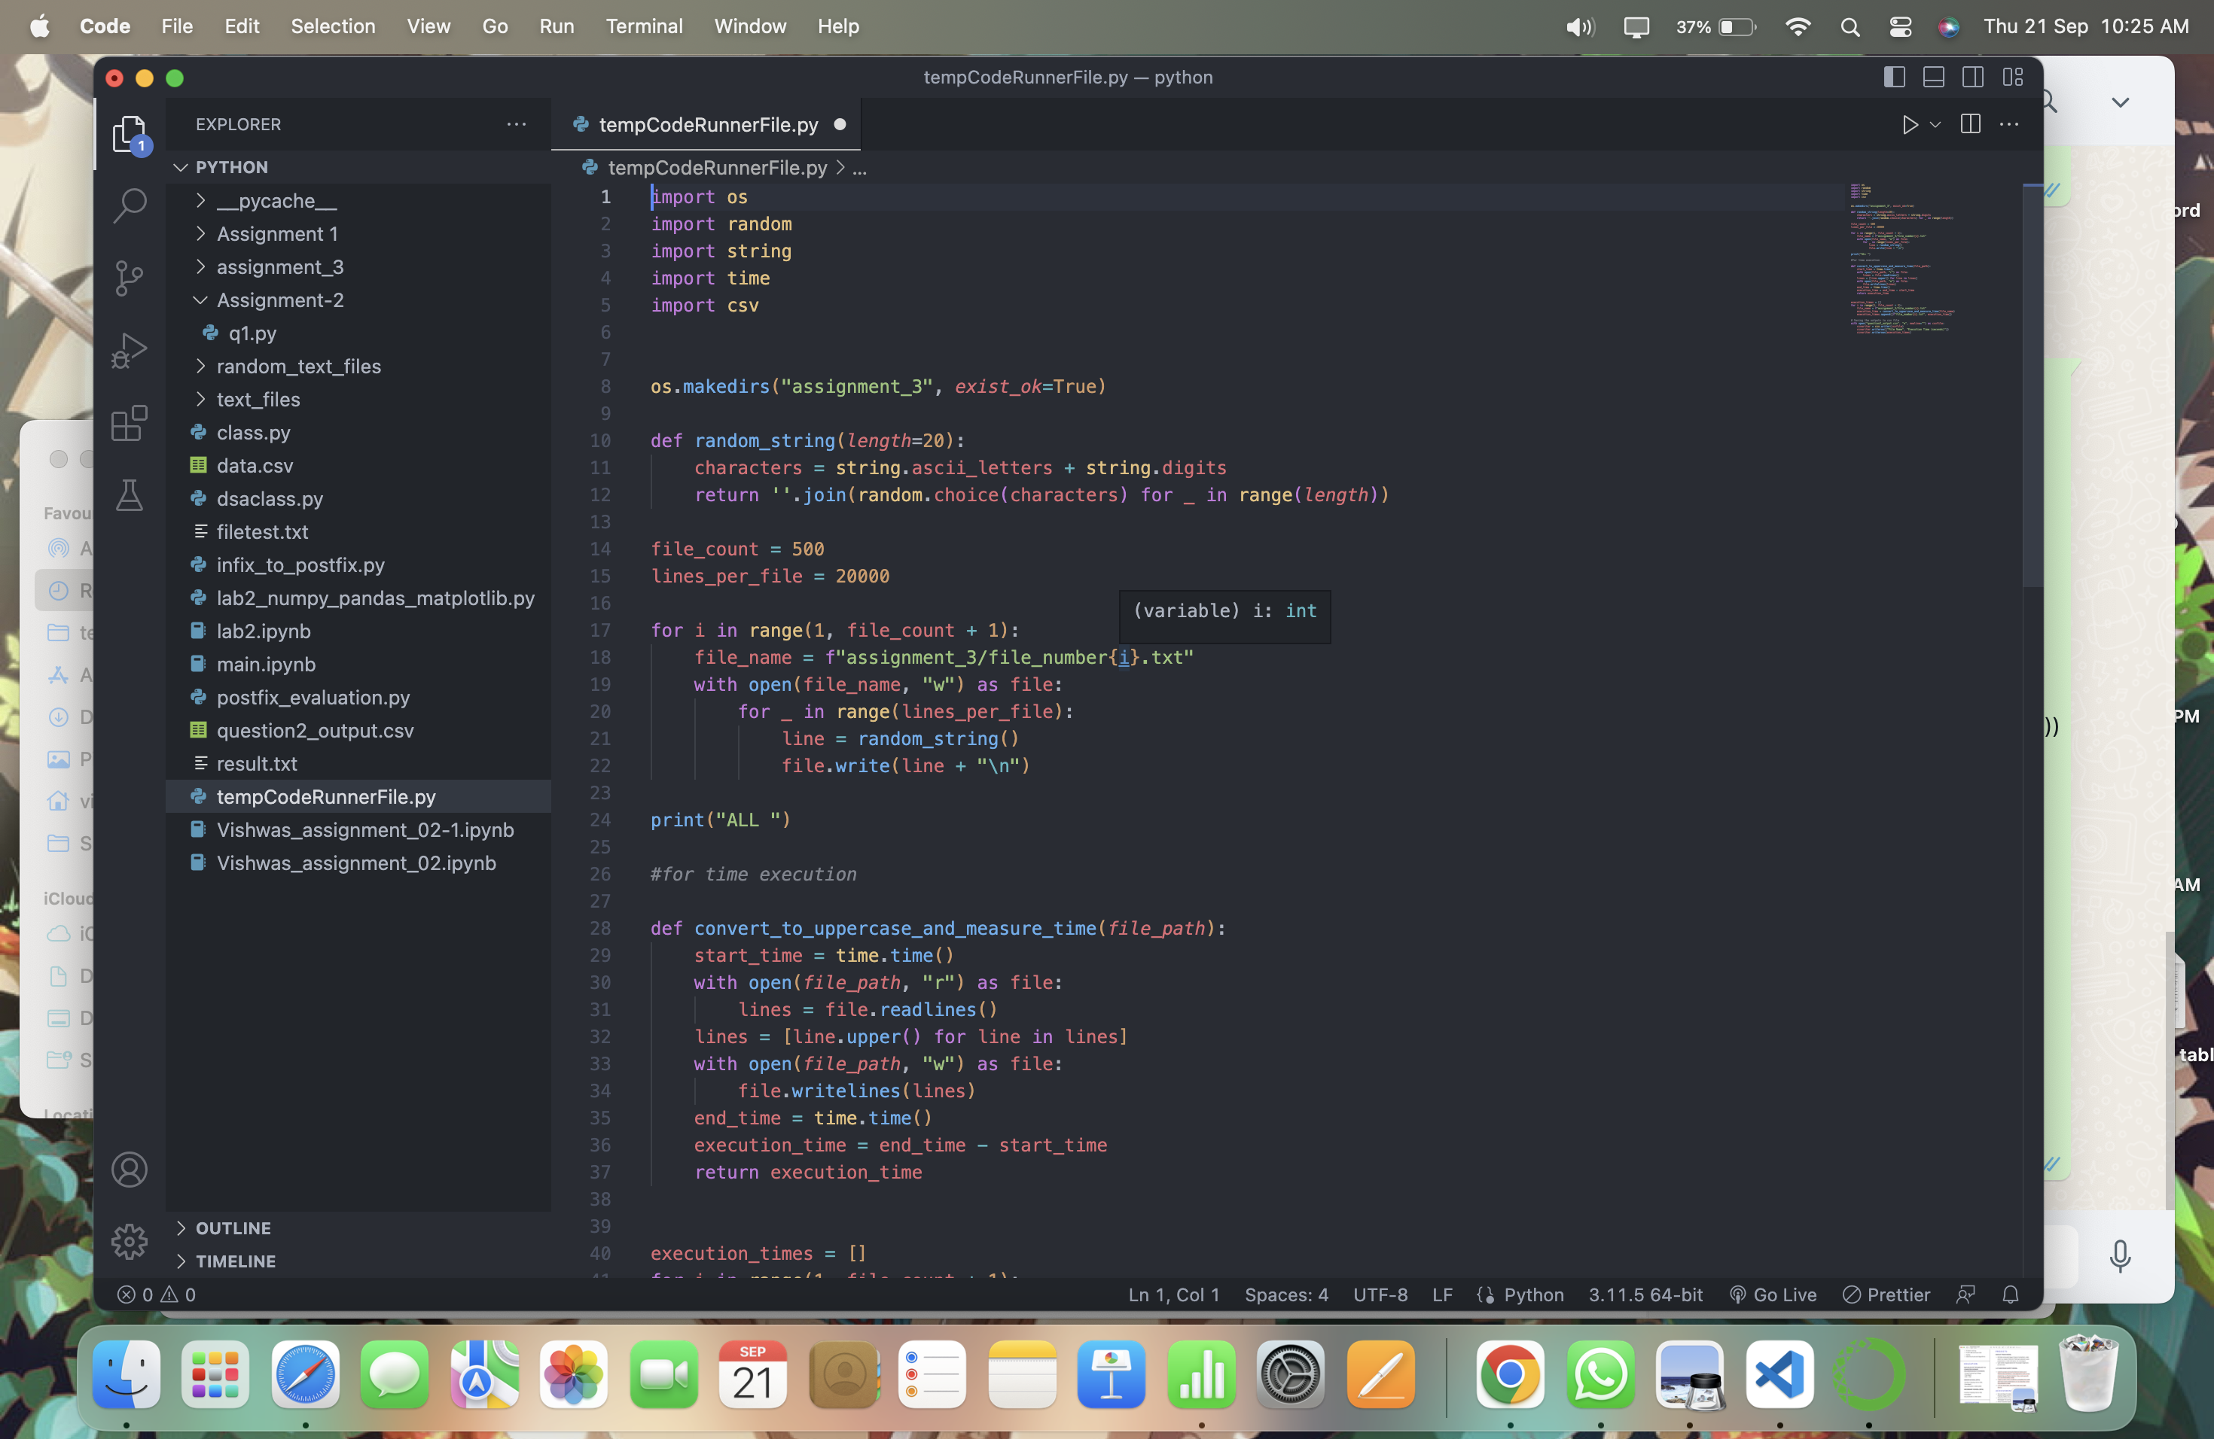

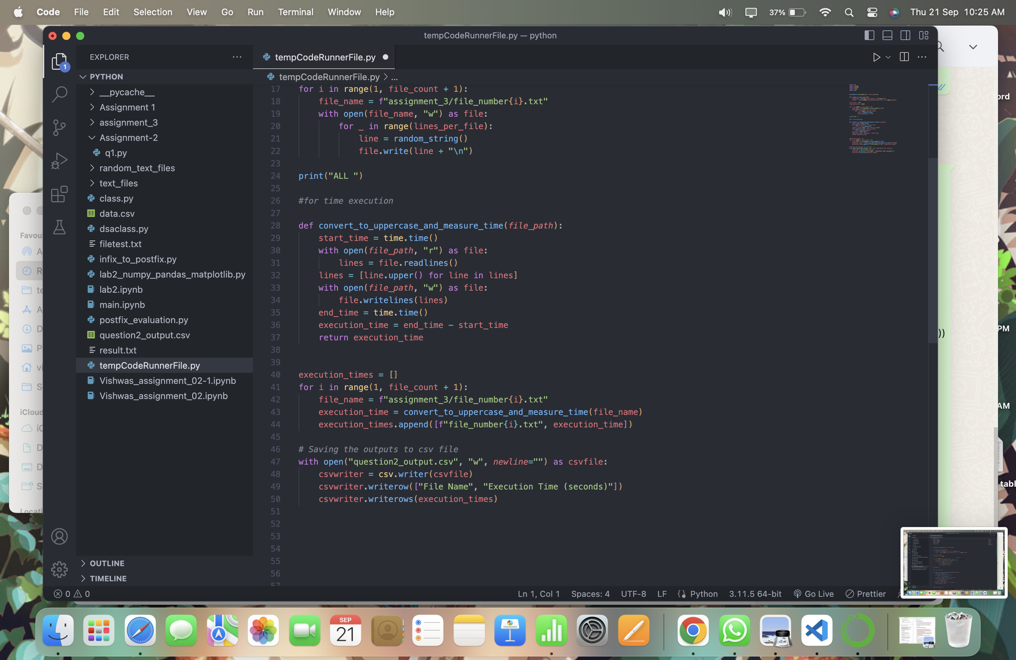

Output is csv file attached: in GCR